Memo

|  |  |
| --- | --- |
| To: | Blythe Masters |
| Date: | October 03, 2015 |
| From: | Jason Kulas and Brian Gunn |
| Subject: | SCUSA Risk Appetite Statement – Auto net charge-off limit |

**Executive summary**

As part of the CART program, we have worked collaboratively across Risk teams and the business at SHUSA and SCUSA to redevelop Risk Appetite Statements for both entities.

Following a presentation to the SCUSA Board on September 22nd, 2015, questions have been raised around the appropriateness of the net charge-off rate limit proposed for the SCUSA Auto lending portfolio. The proposed Auto net charge-off rate levels were lower than the net charge-off rate forecast in SCUSA’s Strategic Plan (P-18), and were thus deemed inappropriate by some stakeholders. There was a concern that the limits would have material impact on SCUSA’s overall business strategy and financial performance.

The purpose of this document is twofold (1) it evaluates the original P-18 loss forecasts and (2) describes the process by which the amber trigger and red limit were developed.

As a result of the collective work with SCUSA and the Risk team, and analysis described in this document, it has been determined that the loss rates in the in the previous P-18 need to be adjusted downwards based on historical and current performance, as explained below.

|  |  |  |  |
| --- | --- | --- | --- |
| **P-18 loss forecast for retained Auto lending** | **2016** | **2017** | **2018** |
| Original P-18 | 8.90% | 9.30% | 9.40% |
| Revised P-18 | 8.40% | 8.95% | 9.00% |

Additionally, it was decided to assume that there would be no dividend payment under a stress scenario, which released ~10 bps of additional loss rate budget. As a result the Risk Appetite Auto charge-off rate levels were increased to 8.6% (red limit) and 7.9% (amber trigger).

The red limit is lower than the revised P-18 numbers for 2017 and 2018. However, it is deemed appropriate for the current state, and the 2015 annual loss rates are well below this limit. The risk appetite loss limits will be recalibrated after the CCAR models and processes – which form a key input – are revised and improved. As such, the red limit of 8.6% will not apply for the full year of 2016 as it will be reevaluated after the CCAR 2016 process.

The new proposed limits are consistent with the P-18 business objectives and do not imply any significant increase in risk or strategic business change for SCUSA.

* * * * *

# **1. Evaluation of the P-18 loss rates**

As a result of the concerns raised around the appropriateness of the proposed risk appetite limits, an evaluation of the loss rates originally recommended for P-18 was conducted, including the following:

1. P-18 analyses were reviewed and a number of limitations were identified
2. Roll-rate models were used to develop an alternative set of projections and additional adjustments were made for:
   1. Bankruptcy sales
   2. Auction recovery rates dropping by 3% from 2015 YTD values
3. Final results were calculated and the P-18 updated as follows:

|  |  |  |  |
| --- | --- | --- | --- |
| **P-18 loss forecast for retained Auto lending** | **2016** | **2017** | **2018** |
| Original P-18 | 8.90% | 9.30% | 9.40% |
| Revised P-18 | 8.40% | 8.95% | 9.00% |

The remainder of this section describes the details of the steps in this process.

1. Limitations of the original P-18 analyses

The P-18 loss forecasts were evaluated and limitations were identified in both the underlying model and analyses.

* 1. Model limitation: development data from a recessionary timeframe

Credit loss forecasting for the P-18 projections was based on the output of the Vintage Loss Model 1.0 (VLM 1.0), which relies on a hazard function segmented by internal Loss Forecasting Score (LFS), and provides the most lift of scores applied to the Auto portfolio by taking into account bureau and loan application variables.

The model uses baseline timing curves as well as observed performance and as such adjusts its forecast every month upon refresh. The development data used in the model spans from 2005 through 2012 and is based on SCUSA’s originations which included the recessionary timeframe. It is believed that the model is overstating forecasted losses.

* 1. Model limitation: over-prediction of seasoned vintages

The actual gross losses at 12 months-on-book are higher than predicted gross losses. However, by 24 months-on-book actual gross losses come close to predicted gross losses. Therefore, it is believed that the model over-predicts on seasoned vintages greater than 12 months-on-book. As such, the vintage model under-predicts losses at 12 months-on-books, but overcompensates for seasoned vintages (greater than 12 months-on-book).

* 1. Higher than historical lagged loss rates

A 12 month lagged rate analysis was performed to measure the impact of a calendar year’s loss rates versus the prior year’s asset base. Under this test it was determined that the maximum loss rate would be ~7% - 9% in the recent economic period. Further, similar analysis of the assumed lag loss rates for the original P-18 would imply an approximate increase in losses of 20-40 basis points to 9.2% - 9.4% compared to the existing lagged run rates (see chart on next page). The revised P-18 is more in line with the actual loss rates displayed below.

# 

Source: “SCUSA trends summary.xlsx”, SCUSA P-18

Note: Lagged yearly net charge-off rates are defined as the current year’s net losses divided by the prior year’s average total outstanding balances

* 1. Business strategy not fully factored into loss forecast

The business has taken on more risk this past year, which is expected to result in a higher loss rate (see chart showing Average Loss Forecasting Score). As a result, higher risk segments were removed from the 2015 strategy, mainly by identifying and removing layered credit risks in August and September 2015. The impact of this is expected to return the loss profile to more normal levels (approximated to be 8–8.5%, see chart showing priced losses).

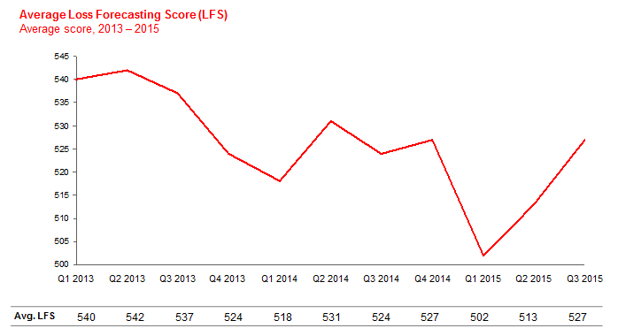

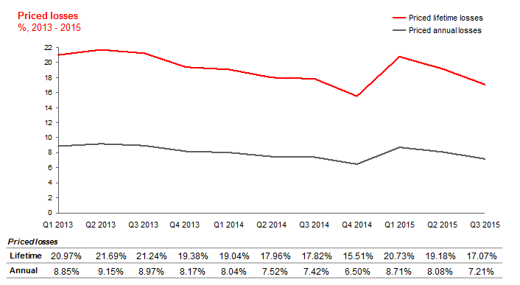

* * * * *

In addition, to ensure that there were no underlining performance issues by scoreband, the 61+ and loss trends were evaluated by score band. It was determined that no significant deviations in performance existed (see below).

**Total Auto Portfolio**

 

# **700+ LFS Score 601 – 700 LFS Score**

 

# **501 - 600 LFS Score <501 LFS Score**



1. Roll-rate models for alternative set of projections and bankruptcy and recovery rate adjustments

Three separate Roll Rates models have been developed: SCUSA Auto Core, Chrysler Non-prime, and Chrysler Prime portfolios. Each model was segmented into similar credit quality loan pools (based on internal LF score). Roll rates have been calculated on a portfolio basis by month. Projections for each month were based on a roll rate observed in the same month 12 months prior e.g., March 2016 31-60 delinquency bucket would be determined by using February 2015 to March 2015 roll rate from 0-30 to 31-60.

Recovery rates were based on 2015 YTD observed recovery rates and adjusted down by a factor of 0.97 based on the trend over the last 14 months. Insurance recoveries were adjusted down as well by a factor of 0.98 based on similar trend. The recoveries are lowered for years 2016 and 2017 and kept at 2017 levels in year 2018. Bankruptcy sales were taken out for the calculation however a cash-flow timing of 30% in year 1, 30% in year 2 and remainder in year 3 has been assumed to account for a lack of accelerated future BK sales. In addition, recovery rate in year 2016 has been further adjusted down by 100bps to account for BK sales that happened in 2015 and effectively lowered 2016 recoveries by moving the cash-flow stream into a one-time sale.

1. Calculation of final results

Based on the above analysis the collective team adjusted the P-18 loss forecast as follows.

|  |  |  |  |
| --- | --- | --- | --- |
| **P-18 loss forecast for retained Auto lending** | **2016** | **2017** | **2018** |
| Original P-18 | 8.90% | 9.30% | 9.40% |
| Revised P-18 | 8.40% | 8.95% | 9.00% |

Source: “SCUSA trends summary.xlsx”

The revised P-18 loss rates are higher than the proposed RAS levels. However, the RAS levels are still deemed to be appropriate for 2015, and current loss rates are well below them. The limits will need to be recalibrated in 2016 after the CCAR models and process – which form a key input – are revised and improved.

.

**2. Approach to calibration of net charge-off rate limits for Risk Appetite**

This section describes the five steps taken to determine the Auto net charge-off rate levels of 8.5% (red limit) and 7.8% (amber trigger) that were presented to the SCUSA Board on September 22nd, 2015. The steps can be summarized as follows:

1. Determine total CCAR loss budget for SHUSA
2. Allocate portion of total CCAR stress loss budget to SCUSA Auto portfolio
3. Determine relationship between CCAR stress losses and baseline (expected) losses
4. Convert stress loss budget to base loss budget, expressed as net charge-off rate
5. Adjust net charge-off rate upwards based on management judgment

The following sections provide a more detailed walkthrough of the steps used to calibrate the Auto net charge-off limit including an explanation of the underlying data, models and calculations.

***Adjustments were made post SCUSA Board meeting on Sept 22nd: it was decided that there would be no dividend payment under an idiosyncratic stress scenario, which released 10 bps of additional loss rate budget. It is proposed to change the Risk Appetite Auto charge-off rate levels to 8.6% (red limit) and 7.9% (amber trigger).***

## Determine total CCAR loss budget for SHUSA

The constraint that anchors risk appetite limits across SHUSA is the need to maintain sufficient capital ratios to be a going concern following severe economic stress. In line with industry practice, SHUSA’s CCAR 2015 analysis was used to establish the maximum combined credit loss and decline in pre-provision net revenue that SHUSA could sustain in an idiosyncratic stress scenario. The maximum loss/decline was based on the most binding regulatory capital ratio – Basel Tier 1 Risk Based Capital ratio. For the risk appetite statement, the minimum ratio was set at 8%, materially above the 6% regulatory minimum, to create a buffer for the known weaknesses in the CCAR process and analytics, and recognizing that the risk profile and asset balances have changed since January 2015 (increasing within SCUSA, which contributes the majority of credit losses to the consolidated SHUSA CCAR). Minimum ratios for other capital metrics (e.g., Common Equity Tier 1 Capital Ratio) were set using a similar approach; all levels were socialized and agreed with Finance.

Having established the most binding capital ratio and the surplus between the CCAR results and the risk appetite statement minimum for this ratio, the capital surplus was allocated pro-rata to portfolios and lines of business to derive the stressed loss budget for each portfolio. It should be noted that this constraint was imposed only at the SHUSA level.

We observed in SHUSA’s CCAR 2015 BHC Stress analysis that credit losses plus PPNR reduction were $13,425 MM in total over the 9 quarter stress forecasting horizon. Taking into account SHUSA’s starting capital position and projected earnings over 9 quarters (which are substantial even in stress), this resulted in a decrease of 356 bps points in the Tier 1 risk-based capital ratio for SHUSA. The amber trigger was set at a level that would allow the SHUSA board sufficient time to agree and execute management actions to avoid breaching the red limit. In dollar terms, this meant that the maximum additional decrease in capital or losses[1] before falling within the amber trigger of the ratio (9%) would be approximately $450 MM, and before falling within the red limit (8%) of the ratio would be approximately $1,350 MM.

Exhibit 1a (included on page 11 of the September 22nd, 2015 presentation to the SCUSA Board) illustrates the capital ratio constraint outlined above.

*Exhibit 1a. Basel Tier 1 Risk-Based Capital Ratio - % under 2015 BHC Stress scenario*



Based on this, an overall CCAR stress loss budget was established for SHUSA of $13,875 MM at the amber level and $14,775 MM at the red level (for 9 quarter cumulative losses, as calculated under the BHC Stress scenario). Sensitivity analysis demonstrates that a 50bps reduction in the red limit corresponds to a 20-30bps increase in the Auto net charge-off threshold. Setting a red limit of 7.0% for SHUSA’s Tier 1 Risk Based Capital ratio, for example, would translate to an Auto net charge-off red limit of 9.0%.

## Allocate portion of total CCAR loss budget to SCUSA Auto portfolio

Next, the stress loss budget described in step A was allocated down to the portfolio level. Each portfolio was initially allocated the stress losses that it generated in the CCAR 2015 analysis. Then, each portfolio received a pro-rata allocation of the capital surplus based on its proportion of the stress losses generated in the CCAR 2015 analysis. (Note: the $600 MM reduction of non-interest income in stress was excluded in performing the allocation, so the denominator used in calculating the proportions was $14,025 MM rather than $13,675 MM). The proportion contributed by the SCUSA Auto portfolio was $6,375 MM or 45.5%.

**It should be noted that the stress losses estimated for SCUSA Auto (and all other portfolios) were based on CCAR 2015 models which are being substantially redeveloped for CCAR 2016. For SCUSA Auto, the credit losses were generated using models developed by Moody’s which are being entirely replaced. We acknowledge that these models could give different results – higher or lower stress losses, or different relationships between base and stress losses. However, at this time the losses from the CCAR 2015 analysis are the best analytic measure available to use for a calibration that links to capital ratios under stress as a binding constraint**.

Exhibit 2a (a version of which was included on page 11 of the September 22nd, 2015 presentation to the SCUSA Board) shows the breakdown of the stress losses calculated in CCAR 2015 and the proportion of the total that each portfolio contributed.

*Exhibit 2a: Credit losses and PPNR impairment & capital surplus allocation - 9Q Cumulative CCAR 2015*

Note: SCUSA Auto portfolio losses / loss budget includes fleet loans classified as C&I.

Putting the different elements together, the amber trigger and red limit for SCUSA’s CCAR loss budget were established as follows:

|  |  |  |
| --- | --- | --- |
|  | **Amber trigger** | **Red limit** |
| SCUSA Auto CCAR stress losses | $6,375 MM | $6,375 MM |
| + Surplus allocation (45.5% of total surplus) | $205 MM | $614 MM |
| = CCAR loss budget (with rounding to nearest $25 MM) | $6,575 MM | $7,000 MM |

## Determine relationship between CCAR stress losses and baseline (expected) losses

The next step to determine a limit on baseline charge-offs that is consistent with the stress loss budget was to understand the relationship between stress losses and baseline (or expected losses). Several data points were examined in this analysis, including the historical relationship of SCUSA-originated Auto loan loss rates – from internal data and also from the SDART securitization program – in normal and stressed economic conditions. Given shifts in the SCUSA portfolio over time to include lower-loss Chrysler loans in the recent “normal” period but not in the prior stress period, the historical comparisons were viewed as giving stress/base multipliers that could be too high. Thus, the relationship observed in the CCAR 2015 analysis was used to set the stress/base multiplier; cumulative BHC Stress losses for the SCUSA Auto portfolio over the 9 quarter stress testing horizon were approximately 1.38x the baseline losses.



**The Risk Appetite limit was set based on the scalar derived from the Moody’s CCAR model in 2014 (1.38X). Actual performance during the great recession was between 1.8X and 2X baseline forecasts. This is a risk as the new models are developed.**

Source: “Auto losses and Delq.xlxs” and “SHUSA CATs” 1. Includes SCUSA Auto fleet loans, captured in C&I in the 14As

## Convert stress loss budget to base loss budget, expressed as net charge-off rate

Based on these inputs, a final calculation was performed to establish the SCUSA Auto credit net charge-off limits. The SCUSA Auto credit net charge-off limit is intended as a business-as-usual limit for normal economic conditions – which could be measured directly on a monthly basis. To create such a business-as-usual metric consistent with the CCAR loss budget, multipliers were applied to convert from stressed losses to baseline losses.

To establish the SCUSA Auto credit net charge-off limits, stress net charge-offs over 9 quarters were annualized linearly, then were converted to baseline implied net charge-offs using the 1.38x loss multiplier derived in step C and a 0.94x multiplier to reflect that balances in the stress scenario were lower than current balances. This calculation resulted in implied annualized net charge-off rates of 7.76% at amber and 8.26% at red. Given the substantial seasonality of net charge-offs in the SCUSA Auto portfolio, the risk appetite limits for net charge-offs and measurement of compliance to these limits were proposed to be established based on a trailing twelve month average calculation. Exhibit 4a, shows the historical charge-off rates observed monthly and on a trailing twelve month average basis; and the calculation steps leading to the baseline net charge-off levels implied as appropriate for amber and red. (Please note that this calculation was performed with exact numbers rather than the rounding reflected at some earlier steps).

*Exhibit 4a: Establishing and backtesting baseline net charge-off limits for SCUSA Auto portfolio*

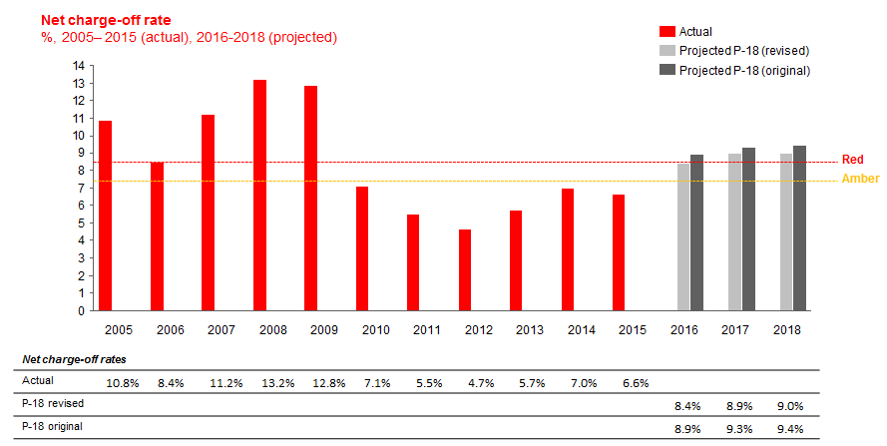

|  |  |  |  |  |  |  |  |  |  |  |  |  |  |  |
| --- | --- | --- | --- | --- | --- | --- | --- | --- | --- | --- | --- | --- | --- | --- |
| ($MM) | **2005** | **2006** | **2007** | **2008** | **2009** | **2010** | **2011** | **2012** | **2013** | **2014** | **2015** | **2016** | **2017** | **2018** |
| **Gross loss** | 296 | 398 | 812 | 1,187 | 1,191 | 842 | 887 | 1,144 | 2,029 | 3,322 | 4,013 | 4,858 | 5,133 | 5,329 |
| **Recovery** | 134 | 192 | 362 | 497 | 505 | 417 | 441 | 598 | 1,007 | 1,714 | 2,205 | 2,492 | 2,621 | 2,802 |
| **Net loss** | 162 | 206 | 449 | 690 | 686 | 425 | 447 | 546 | 1,023 | 1,607 | 1,808 | 2,365 | 2,511 | 2,526 |
| **Avg Bal.** | 1,497 | 2,434 | 4,017 | 5,239 | 5,357 | 5,964 | 8,157 | 11,740 | 17,807 | 23,022 | 27,208 | 28,182 | 28,046 | 28,124 |
| **Asset sales** | - | - | - | - | - | - | - | - | 2,450 | 5,315 | 3,691 | - | - | - |
| **BK sales** | - | - | 7 | - | 0 | - | 41 | 9 | 122 | 27 | 102 | - | - | - |
| **Avg61+%** | 6.2% | 4.9% | 6.2% | 7.9% | 8.3% | 6.3% | 4.3% | 4.0% | 4.3% | 4.8% | 4.7% | - | - | - |

*Note: 2015 is YTD annualized and 2016-2018 are from the current P-18*

*Source: SCUSA trends summary.xlsx*

 [2]

The stress to baseline loss relativity (or stress scalar in the table above) is a large driver of the net charge-off rate limits. Thus, a sensitivity analysis was performed to explore how the net charge-off rate limit would change given different relativities. For example, using a 1.8X relativity – as implied by historical net charge-off rates in crisis and normal conditions – would yield an amber trigger of 6.0% and a red limit of 6.3%. In contrast, using a 1.18X relativity – as implied by the CCAR 2015 projected losses for BHC Stress over BHC Baseline – would yield an amber trigger of 9.1% and a red limit of 9.7%. As a reminder, the relationship observed in the CCAR 2015 analysis that cumulative BHC Stress losses for the SCUSA Auto portfolio over the 9 quarter stress testing horizon were approximately 1.38X the baseline losses was used to set the stress/base multiplier. This compares to a stress to baseline loss relativity of approximately 1.8-2X experienced in the Great Recession. **Furthermore, the new, enhanced CCAR models currently under development may forecast a higher stress to baseline loss relativity than in the current model.**

## Adjust based on management judgment

The final step in setting the SCUSA Auto credit stress loss limit was an incorporation of management judgment. While the amber trigger of 7.8% calculated above was deemed acceptable, the red limit was judgmentally adjusted upward to 8.5% to allow additional flexibility for business growth during a meeting attended by the SCUSA CRO on 09/01/2015. Given this ~25bps adjustment was modest (less than 3% of the 8.26% suggested from the calculations above); and if scaled to stress losses by reversing the steps above would only result in approximately $200 MM in incremental losses over 9 quarters – which was anticipated to be offset by future reductions of losses in the SCUSA Unsecured portfolio; this was deemed a reasonable adjustment.

***Adjustment made post SCUSA Board meeting on Sept22nd:***

*CCAR projections included dividend payments by SCUSA of $440MM at the SCUSA level, which translate to a net $178MM depletion of capital at SHUSA. With capital actions included, the CCAR 9Q minimum for the Tier 1 Risk-based Capital ratio is 9.48%, translating to a capital surplus is ~$450MM. Without capital actions, the CCAR 9Q minimum for the Tier 1 Risk-based Capital ratio is 9.67%, growing the capital surplus by $178MM. As shown below, $81MM of the additional capital surplus is allocated to SCUSA Auto credit losses under stress, which translates into a net charge-off rate limit that is 10bps higher.*

|  |  |  |  |  |  |  |
| --- | --- | --- | --- | --- | --- | --- |
|  | **Amber trigger** | | | **Red limit** | | |
| **SCUSA Auto** | **With capital actions** | **Without capital actions** | **Delta** | **With capital actions** | **Without capital actions** | **Delta** |
| Loss budget | $6,573MM | $6,653MM | $81MM | $6,990MM | $7,071MM | $81MM |
| NCO rate limit | 7.76% | 7.86% | 0.10% | 8.26% | 8.35% | 0.10% |

*It was decided that there would be no dividend payment under an idiosyncratic stress scenario, which released 10 bps of additional loss rate budget. It is proposed to change the Risk Appetite Auto charge-off rate levels to 8.6% (red limit) and 7.9% (amber trigger).*

1. SHUSA tax department indicated that at this extreme level of losses, there would be no tax benefit realizable in capital ratios from incremental losses; so additional losses effectively hit capital dollar for dollar.
2. The outstanding balances are as of July 2015